Bug 1:

**Summary:** The Page was not found.

**Description:** After I'm clicking on a link, a new page appears with the message "Error 404 Page".

**Steps:**

**1.** Go to https://www.evozon.com/.

**2.** Scroll down until you reach the bottom of the page.

**3.** From JOB OPPORTUNITIES, choose Python Developer and click on it.

**Expected Results**: After clicking on Python Developer, a new page should appear with information about available jobs for python developers.

**Actual Results**: A new page appears with the message "Error 404 Page".

**Screenshot:**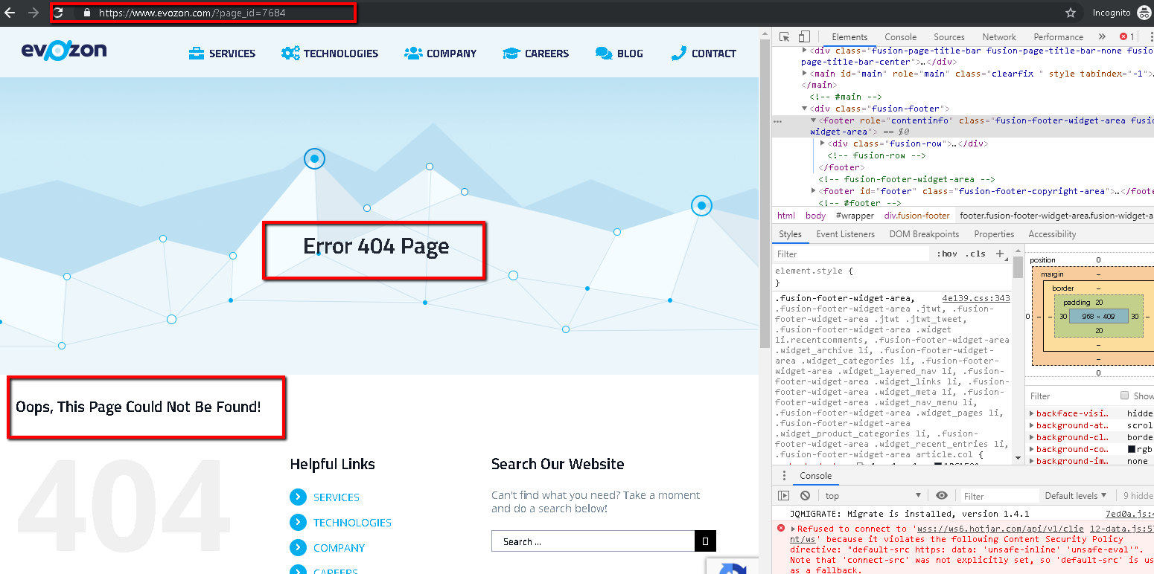

**Severity:**Major.

**OS:** Windows 10.

**Browser:** Google Chrome Version 73.0.3683.

**Bug 2:**

**Summary:** The Page was not found.

**Description:** After I'm clicking on a link, a new page appears with the message "Ne pare rau, pagina nu exista!".

**Steps:**

**1.** Go to https://www.evozon.com/.

**2.** From SERVICES, choose Game Studio and click on it.

**3.** Scroll down until you reach the bottom of the page.

**4.** Find the Twitter button and click on it.

**Expected Results:** After clicking on the Twitter button,the twitter page of Game Studio should appear.

**Actual Results:** A new page appears with the message "Ne pare rau,pagina nu exista!".

**Screenshot:**

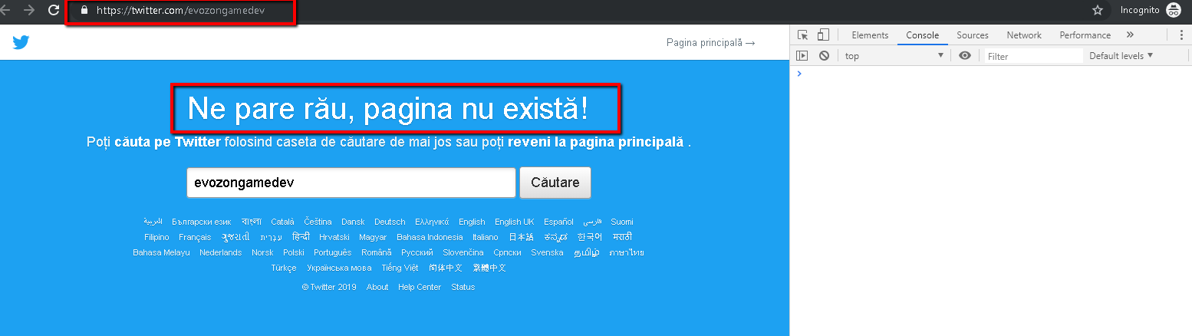

**Severity:**Major.

**OS:**Windows 10.

**Browser:** Google Chrome Version 73.0.3683.